**Chapter 1: Introduction**

**1.1 Introduction**

Chess, often referred to as the "Game of Kings," has a rich history that dates back over a millennium. This timeless game, characterized by its strategic complexity and intellectual challenge, has captivated players from all walks of life. With the advent of digital technology, chess has transformed significantly, evolving from a traditional board game into a dynamic online experience. Today, millions of players engage in multiplayer online chess games, connecting with opponents worldwide and participating in vibrant communities.

The rise of online chess platforms has democratized access to the game, allowing players to enjoy chess anytime, anywhere. These platforms offer a variety of features, including real-time matchmaking, interactive tutorials, and community forums. However, despite their popularity, existing online chess platforms face several challenges. Players often encounter issues such as poor matchmaking, limited user engagement, and concerns about cheating, which can detract from the overall gaming experience.

This report outlines the development of a multiplayer online chess game designed to address these challenges. The project focuses on creating a user-friendly interface, implementing a robust matchmaking algorithm, and enhancing player engagement through interactive features. The following sections will detail the problem statement, objectives, scope, limitations, development methodology, and organizational structure of the report.

**1.2 Problem Statement**

While online chess has made the game more accessible, players still face several challenges that hinder their experience. Key issues include:

* **Lack of Simple Multiplayer Chess Options**: Many existing chess platforms are either overly complex or lack the simplicity required for casual users.
* **Real-Time Gameplay Issues**: Achieving smooth, real-time gameplay is challenging without the proper technology, leading to a less enjoyable user experience.
* **Accessibility for Casual Players**: There is a need for a straightforward chess platform that focuses on core gameplay without overwhelming users with additional features.

**1.3 Objectives**

* **To create a simple and accessible multiplayer chess game** that allows users to connect and play against each other in real-time using WebSockets, ensuring smooth and responsive gameplay.
* **To provide a distraction-free platform** focused on basic chess functionality, catering to players who prefer a straightforward and easy-to-use interface.
* **To deliver a reliable and efficient application** by using modern web technologies, ensuring that the game is accessible to a wide range of users across different devices.

**1.4 Scope and Limitation**

#### **Scope**

1. **Core Functionality**: The platform is designed to provide a simple and accessible online chess game, focusing on essential chess gameplay without additional distractions or advanced features.
2. **Real-Time Gameplay**: Utilizing WebSocket technology, the platform ensures smooth and responsive bidirectional communication for real-time player interactions.
3. **User-Friendly Interface**: A distraction-free, straightforward interface is prioritized to make the platform accessible and appealing to casual players.
4. **Matchmaking**: The platform supports basic matchmaking to connect players for quick games.
5. **Cross-Device Compatibility**: Developed with modern web technologies, the platform is optimized for use across various devices, including desktops, tablets, and mobile phones.

#### **Limitations**

1. **Lack of Cheat Detection**: The platform does not include cheat detection mechanisms. Players are expected to follow fair play practices voluntarily.
2. **No Advanced Features**: Features such as in-game chat, move analysis, or AI-driven insights are intentionally excluded to maintain simplicity and focus on core gameplay.
3. **Basic Matchmaking Only**: Matchmaking is limited to connecting available players without advanced ranking systems or skill-based pairing.
4. **No Offline Play**: The platform requires an active internet connection, as all interactions are conducted in real-time through WebSocket technology.
5. **Limited Community Features**: Community engagement is facilitated through gameplay but lacks forums, leaderboards, or extensive social features.
6. **Focus on Casual Players**: The platform is not designed for advanced players seeking features like tournaments, chess puzzles, or professional-grade analysis tools.

By defining the scope and limitations, the project aims to deliver a straightforward and efficient platform that meets the needs of casual chess players while maintaining simplicity and accessibility.

**1.5 Development Methodology**

The methodology followed in this project is **Incremental Development**, where the application is built and tested in stages:

* **Implementation of Core Features**: Starting with essential features such as user authentication and gameplay mechanics.
* **Integration of WebSocket Synchronization**: Adding real-time communication to enable multiplayer functionality.
* **Validation and Testing**: Testing game logic, including move validation and rule enforcement using **python-chess**. [6]
* **Scalability Enhancements**: Optimizing backend storage and synchronization using Redis and Django Channels .
* **Frontend Enhancements**: Refining the user interface for a responsive and clean design.

This iterative approach allows incremental testing and improvement, ensuring a robust and user-friendly application. ​

**Chapter 2: Background Study and Literature Review**

**2.1 Background Study**

The study of chess encompasses both theoretical concepts and practical implementations. This section presents a fundamental overview of the key theories, general concepts, and terminologies pertinent to the development of a multiplayer online chess game.

**2.1.1 Fundamental Theories**

1. **Game Theory**: Game theory is the study of strategic interactions among rational decision-makers. In chess, players must anticipate their opponent’s moves and develop strategies accordingly. Concepts such as Nash Equilibrium can be applied to understand optimal play in chess.
2. **Artificial Intelligence (AI) in Games:** The application of AI techniques in chess has a long history. Algorithms like Minimax and Alpha-Beta pruning are crucial for developing AI opponents that can compete with human players. More advanced techniques involve machine learning, particularly neural networks, which have been used in projects like AlphaZero.
3. **Network Theory:** Multiplayer online chess requires a solid understanding of network protocols and client-server architecture. Concepts such as latency, bandwidth, and data integrity are critical for ensuring a smooth gaming experience.
4. **User Interface Design:** A well-designed user interface (UI) enhances player experience. UI principles such as usability, accessibility, and aesthetics must be considered when developing the chess game interface.

**2.1.2 General Concepts**

1. **Chess Rules:** Understanding the basic rules of chess, including piece movements, check, checkmate, stalemate, and special moves like castling and en passant, is essential for both game design and player engagement.
2. **Multiplayer Mechanics:** Implementing multiplayer functionality involves managing sessions, player authentication, and real-time game updates. Concepts such as turn-based play, matchmaking, and leaderboard systems are integral to the multiplayer experience.
3. **Game State Management:** The game state represents the current position of all pieces on the chessboard, player turns, and other game variables. Efficient management of the game state is crucial for real-time updates and ensuring consistency across different players’ views.

**2.2 Literature Review**

This section reviews relevant literature, projects, and findings from other researchers that contribute to the development of multiplayer online chess games.

**2.2.1 Similar Projects**

**a) Lichess**

Lichess is a widely recognized open-source chess platform that provides real-time gameplay using WebSocket technology. It offers an extensive range of features such as various chess modes, puzzles, tournaments, and in-depth analysis tools. However, this abundance of features can overwhelm users who are looking for a straightforward and distraction-free playing experience. Additionally, while the platform is generally efficient, the high volume of users, especially during peak times, can lead to occasional performance slowdowns and latency issues.

**b) Chess.com**

Chess.com is one of the most popular platforms for online chess, boasting a vast array of features including multiplayer games, tutorials, puzzles, AI opponents, and tournaments. While these features make the platform versatile, the interface can feel cluttered and intimidating for casual users. Moreover, many advanced tools, such as game analysis and personalized coaching, are locked behind a premium subscription, which limits accessibility for users seeking a fully free and straightforward chess solution. This can make it less appealing to users who prefer simplicity without monetary commitments.

#### **c) Playchess**

#### Playchess is a more minimalistic platform aimed at connecting chess players online for direct matches. It emphasizes basic functionality over advanced features, making it appealing to those seeking simplicity. However, the platform's reliance on manual server connections can be a significant hurdle for users who are not technically inclined or unfamiliar with such systems. Furthermore, it lacks modern matchmaking features, which can make finding an opponent less efficient compared to other platforms.

#### **d) Chess24**

Chess24 offers a comprehensive chess experience with features including live streaming of professional games, puzzles, tutorials, and interactive lessons. The platform also allows users to play online matches against others or AI opponents. While it is popular among serious chess enthusiasts, its advanced features and focus on professional chess can be overwhelming for casual players. Additionally, many of its premium features, such as in-depth game analysis and exclusive video content, are only accessible through a subscription, which might deter users looking for a free, no-frills platform.

**CHAPTER 3: SYSTEM ANALYSIS**

**3.1 System Analysis**

For the development of the chess game, the **Incremental Model** was chosen due to its advantages in delivering the game in manageable parts while allowing flexibility and timely feedback. This approach allows us to build the game incrementally, with each iteration or increment adding new functionality and improving the game. The following sections describe the methodology and the rationale for using the Incremental Model in the development of the chess game.

**3.1.1. Requirement Analysis**

**i. Functional Requirement**

**I) Real-Time Gameplay:**

* The system must provide smooth, real-time synchronization of the chessboard between two players using WebSocket technology.
* Ensure all moves are reflected immediately for both players, with validations applied to ensure the legality of moves.

**II) Multiplayer Match Initialization:**

* Allow players to create or join matches via a unique session link or game ID.
* Simplify the process of connecting two players, ensuring accessibility for non-technical users.

**III) Basic Chess Functionality:**

* Include essential chess rules and mechanics (e.g., check, checkmate, stalemate) using the python-chess library.
* Provide clear feedback to players when a move is invalid or when the game ends.

**IV) Game State Persistence:**

* Ensure that the game state is saved during active matches to allow players to reconnect in case of disconnections.
* Store completed game logs temporarily for review or reference.

**V) Clean and Simple Interface:**

* Design a minimalistic interface that displays only the chessboard, player names, and game status.
* Avoid unnecessary features or distractions.

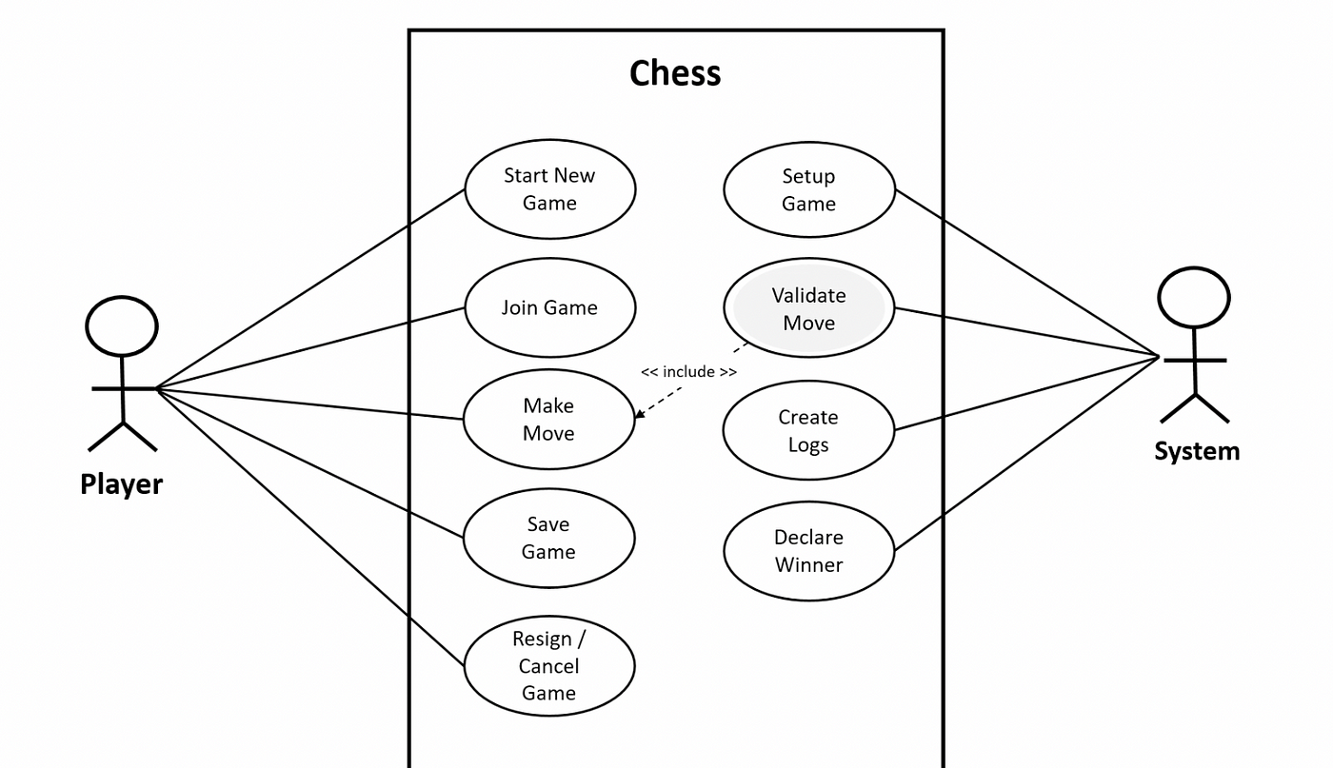

**Figure 3. 1: Use Case Diagram for Functional Requirement**

**ii. Non-functional requirement**

**I) Performance**

* The application should ensure fast data processing and low latency for real-time gameplay, with WebSocket updates occurring within 100 milliseconds.
* The chessboard and game interface must load within 2 seconds to maintain a smooth user experience.

**II) Scalability**

* The system must handle an increasing number of concurrent games efficiently by managing WebSocket connections effectively.
* It should be designed to support additional features in the future without significant architectural changes.

**III) Compatibility**

* The application must function seamlessly across all major web browsers, including Chrome, Firefox, Safari, and Edge.
* It should also provide a responsive design that adapts to desktops, tablets, and smartphones, ensuring a consistent user experience.

**IV)Usability**

* The interface must be simple and intuitive, catering to players of all skill levels.
* It should feature a clean layout focused on the chessboard and essential game information, avoiding unnecessary distractions or complex navigation.

**V) Security**

* The system must ensure secure WebSocket communication, encrypting all transmitted data to protect game states and user information.
* It should implement secure authentication methods to prevent unauthorized access to game sessions.

**3.1.2 Feasibility Analysis**

**i. Technical Feasibility**

The Multiplayer Chess Game uses popular tools like HTML, CSS, JavaScript, andPython, which is widely known and easy to learn. Django, used for the backend, ishighly accessible, with many tutorials, books, and online videos available forguidance. For real-time communication, WebSockets are implemented using DjangoChannels, which are well-documented and simple to integrate. Redis is chosen for its fast performance and ease of use, making it ideal for storing game states. This combination of tools ensures the project is technically feasible and easy to maintain.

**ii. Operational Feasibility**

The application is built to work on both computers and mobile devices, ensuring players can access the game from any platform. Its clean and simple interface makes it easy to use for players of all skill levels, including those who are new to online chess. Hosting the game on a cloud platform ensures it is always available, and regular updates will be planned to keep the application running smoothly. This design ensures the project meets the needs of users without requiring complex navigation or technical knowledge.

**iii. Economic Feasibility**

The project uses free tools and technologies, making it affordable to develop and deploy. Costs will primarily involve hosting the application, which is minimal due to its lightweight nature. By focusing on core features without unnecessary complexity, the project offers a cost-effective solution that provides value to users. This approach ensures the project remains budget-friendly while delivering a simple and reliable chess platform.

**iv. Schedule Feasibility**

The game can be developed in stages, with each increment contributing to a working version of the game. Each increment can be completed in a set period, allowing for a predictable schedule of releases and updates.  
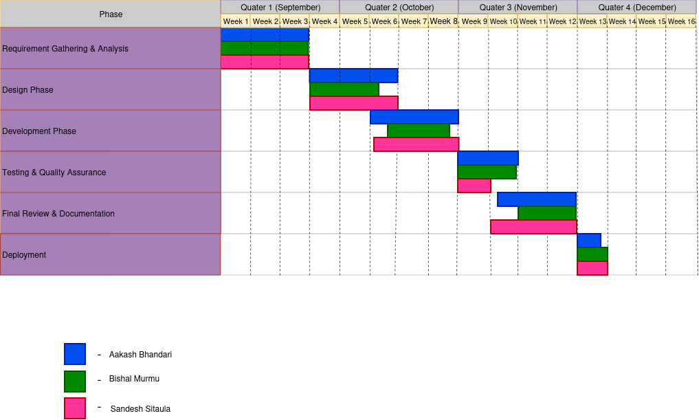

**Figure 3. 2: Gantt Chart**

**3.1.3 Analysis**

**i) Data modeling using E-R Diagram**  
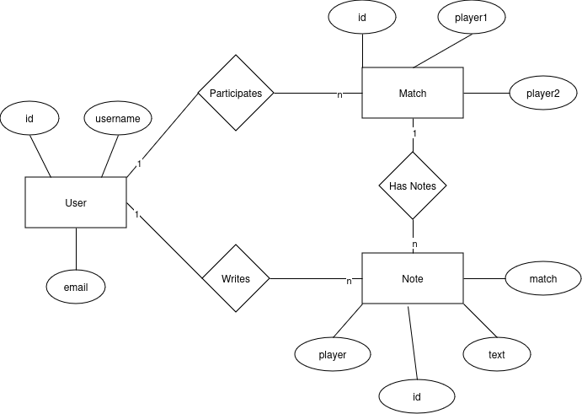

**Figure 3. 3: E-R diagram**

**ii) Level 0 DFD**

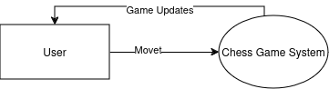

**Figure 3. 4: Level 0 Data Flow Diagram**

**iii) Level 1 DFD**

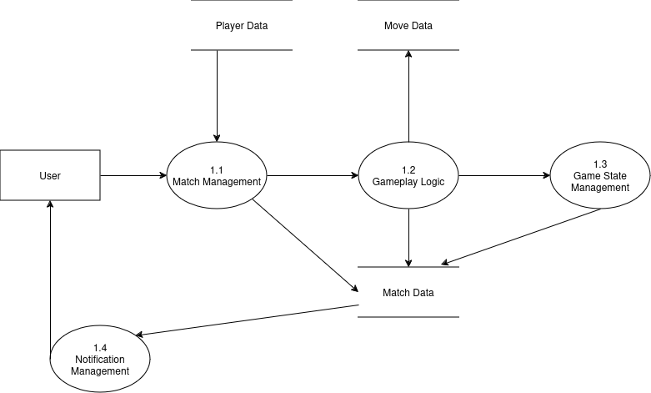

**Figure 3. 5: Level 1 Data Flow Diagram**

**CHAPTER 4: SYSTEM DESIGN**

**4.1.1) Database Design (Transformation of ER to Relation Diagram)**

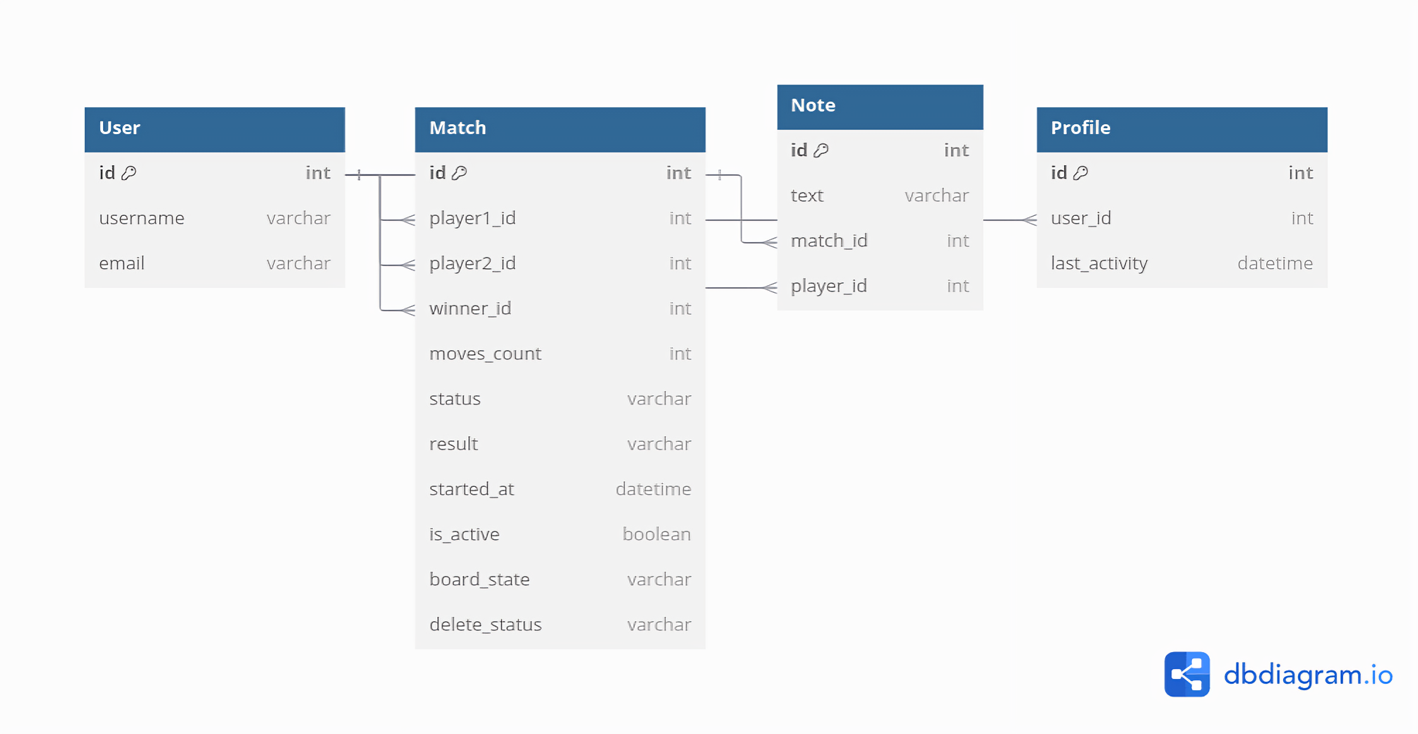

**Fig 4.1) Relation Diagram**

**4.1.2) Illustrative Diagram System Design**

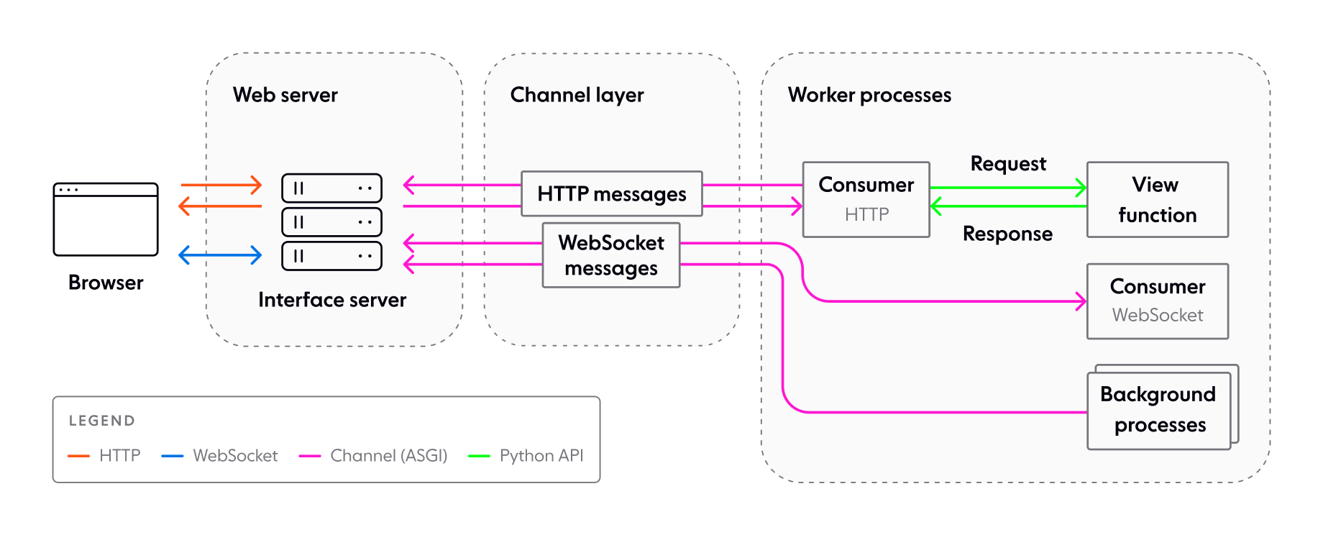

**Figure 4.2) Illustrative Diagram1**

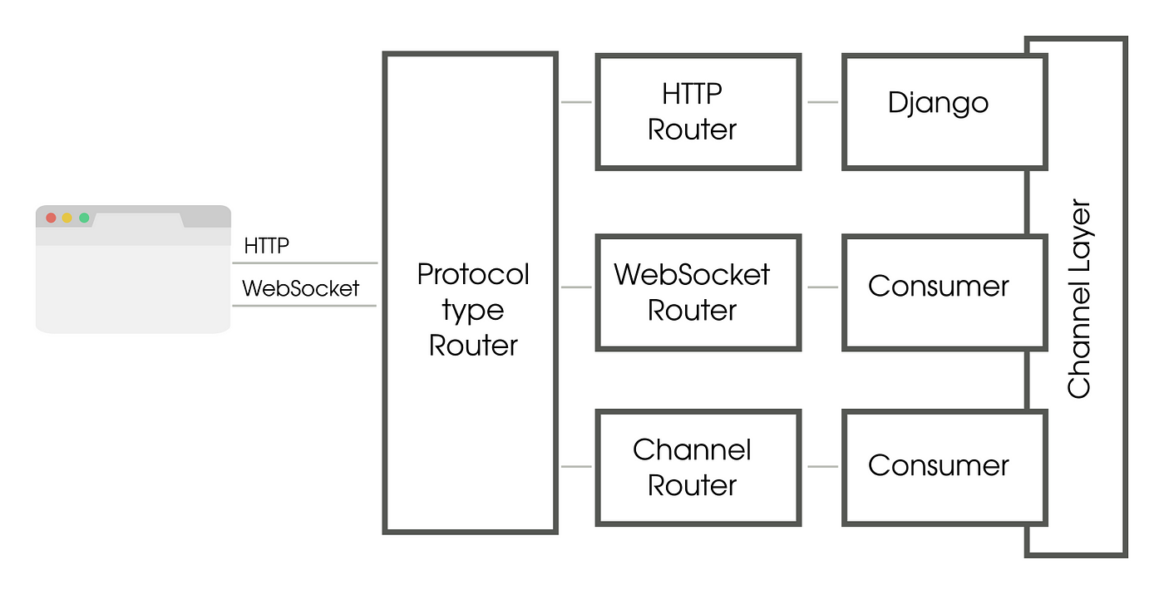

**Figure 4.3) Illustrative Diagram2**

**4.2) Algorithm Details**

**4.2.1) Chess Synchronization Algorithm (WebSocket-Based)**

**Overview:**The synchronization algorithm ensures that the chessboard state remains consistent for both players in real time, handles simultaneous move attempts, and manages player reconnections.

**Steps in the Algorithm:**

1. **Player Move Submission:**
   * Player A makes a move and sends it to the server over a WebSocket connection.
2. **Validation of Move:**
   * The server validates the move using the **python-chess** library. [6]
   * If the move is illegal, the server sends an error message back to Player A, and the state remains unchanged.
3. **Game State Update:**
   * If the move is valid:
     + The server retrieves the current game state from Redis.
     + Applies the move to the game state.
     + Saves the updated state back to Redis using atomic operations to prevent conflicts.
4. **Broadcast Update:**
   * The updated game state is sent to both Player A and Player B over WebSocket connections.
5. **Reconnection Handling:**
   * If a player disconnects, the server keeps the game state in Redis.
   * Upon reconnection, the server retrieves the latest game state and sends it to the player to resume the match.

### **4.2.2) Checkmate Detection Algorithm**

The **Checkmate Detection Algorithm** determines whether a player's move has resulted in a checkmate, signaling the end of the game. This algorithm validates the current board state after each move and declares the appropriate result if a checkmate condition is met.

#### **Steps:**

1. **Move Execution**
   * After a player makes a move, the server applies the move to the current game state (chessboard) and evaluates the board.
2. **Check Detection**
   * The algorithm first checks if the opponent's king is in a state of check:
     + A king is in check if it is under immediate threat from any opposing piece.
     + This validation is done using the rules of chess or a library like python-chess.
3. **Legal Moves Evaluation**
   * If the opponent's king is in check, the algorithm evaluates all possible legal moves for the opponent:
     + If no legal moves exist that can remove the king from check, it is a checkmate.
     + If legal moves are available, the game continues as usual.
4. **Checkmate Confirmation**
   * When the algorithm confirms a checkmate:
     + The server declares the player who delivered the checkmate as the winner.
     + The game is marked as completed in the database or game state store.
5. **Game State Update**
   * The server updates the game state to reflect the checkmate:
     + The final board state is stored.
     + The result is recorded as "Checkmate."
     + The winner's details are saved.
6. **Result Broadcasting**
   * The server sends the final game state and the result to both players:
     + This includes the winning player's identity and the board position at the time of checkmate.
7. **Edge Cases**
   * If the game ends in checkmate but both players' timers expire simultaneously, the server determines the result based on timing priority or a pre-defined rule.
   * If a player resigns after delivering a checkmate, the resignation takes precedence.

**4.2.3) Minimax Algorithm with WebSockets and python-chess**

**Algorithm Steps:**

1. Initialization

i) Start the WebSocket server.

ii) Initialize the chessboard using python-chess

iii) Set the depth for the Minimax algorithm (e.g., 2 or 3).

iv) Define the evaluation function to score board states based on material advantage (e.g., pawns = 1, queens = 9).

2. Player’s Move

i) Receive Move:

* Wait for the player to send a move in UCI format (e.g., e2e4) via WebSocket.

ii) Validate Move:

* Parse the move using python-chess.
* Check if the move is in the list of legal moves:
  + If invalid, send an error message back to the player.
  + If valid, apply the move to the chessboard using board.push().

iii) Check Endgame Conditions:

* Use board.is_game_over() to check for game-ending conditions (checkmate, stalemate, etc.).
* If the game is over, send the result (checkmate, stalemate, etc.) to the player and end the game.

3. AI’s Turn

i) Simulate All Possible Moves:

* For each legal move the AI can make:
  + Apply the move to the chessboard using board.push().
  + Call the Minimax function recursively to evaluate the move.

ii) Evaluate Board State:

* At the base case of the recursion (depth = 0 or game over):
  + Use the evaluation function to assign a score to the current board state.
    - Positive scores favor the AI.
    - Negative scores favor the opponent.

iii) Backpropagate Scores:

* For the maximizing player (AI):
  + Return the maximum score among all possible moves.
* For the minimizing player (human):
  + Return the minimum score among all possible moves.

iv) Prune Irrelevant Branches:

* Use Alpha-Beta Pruning to skip branches of the game tree that cannot influence the final decision.

v) Select the Best Move:

* The move with the highest score from the root node is chosen as the AI’s move.

vi) Apply AI’s Move:

* Apply the selected move to the chessboard using board.push().
* Send the AI’s move to the player via WebSocket.

4. Repeat

i) Alternate turns between the player and the AI.

ii) Repeat until the game ends:

* Either due to checkmate, stalemate, or resignation.

iii) Send the final game result to the player.

**4.4.5) Flowchart of Gameplay / Working Mechanisms**

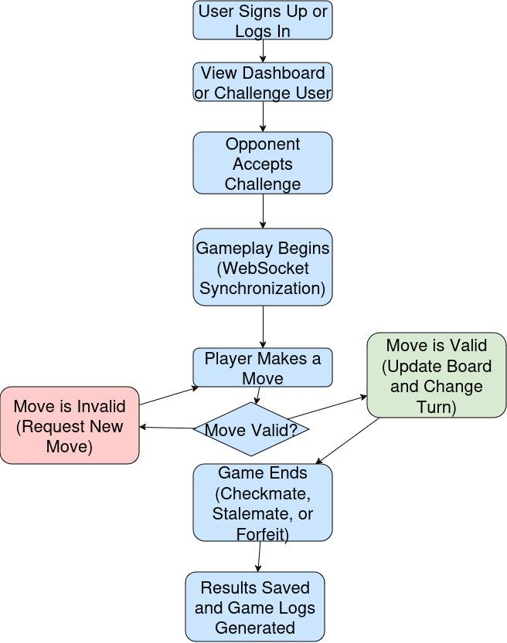

**Figure 4.4) Flowchart of system implementation**

**5) Implementation And Testing**

**5.1) Implementation**

**5.1.1) Tools Used**

**i) Backend Framework: Django 4.2.16**

**ii) Programming Language: Python 3.12**

**iii) Communication Protocol: Websockets**

**iii) Library To implement WebSocket Protocol: Django Channels 4.1.0**

**iv) Database Platform: Sqlite3**

**v) Channel Layer: redis**

#### **i) Backend Framework: Django 4.2.16**

We chose Django because of its robust ecosystem, built-in features, and seamless integration with tools like Django Channels. It follows the MVC (Model-View-Controller) architectural pattern, which is highly suitable for organizing our application. Django's ORM makes database interactions efficient, while its settings module and middleware simplify configuration and security. Templates are used to dynamically generate the front-end, while ASGI support ensures compatibility with WebSocket communication. This setup ensures a scalable and maintainable backend structure. Also the resources and community for the Django ecosystem is quite large which makes problem solving easier incase of issues in future.

#### **ii) Programming Language: Python 3.12**

Python was selected for its readability, extensive library support, and strong community backing. Mainly the language's asynchronous capabilities (async/await) are critical for handling WebSocket connections efficiently in our application. Python's compatibility with frameworks like Django further simplifies backend development. Database operations cannot be used in websockets directly because of its synchronous nature so python latest version further helps in this type of orm operations. [7]

#### 

#### 

#### 

#### **iii) Communication Protocol: WebSockets**

WebSockets were used to enable real-time, bidirectional communication between the client and the server. This protocol minimizes latency and eliminates the need for repeated HTTP requests, making it ideal for features like player challenges, real-time game state updates, and move handling. Compared to traditional polling mechanisms, WebSockets are more resource-efficient and provide a smoother user experience.

#### **iv) Library for Implementing WebSocket Protocol: Django Channels 4.1.0**

Django Channels extends Django’s capabilities to support asynchronous protocols like WebSockets. It was chosen to abstract away lower-level complexities, such as channel layers and protocol handling, allowing us to focus on application logic. The AsyncWebsocketConsumer class from channels.generic.websocket was used in consumer_gameplay.py and consumer_home.py to handle WebSocket connections. Django Channels integrates seamlessly with Django’s authentication system, enabling us to retrieve user information during WebSocket sessions using the AuthMiddlewareStack.

#### **v) Database Platform: SQLite3**

SQLite3 was chosen as the database for development due to its simplicity and zero-configuration setup. It is integrated into Django by default, allowing quick prototyping without requiring an external database. SQLite3's lightweight nature makes it suitable for testing and smaller-scale applications. In future it can be switched to a more robust option like PostgreSQL incase sqlite3 cannot handle load.

#### **vi) Channel Layer: Redis**

Redis was selected as the channel layer backend due to its high performance and reliability in managing real-time messaging. It enables communication between different consumers through pub/sub mechanisms, ensuring scalability and responsiveness in WebSocket implementations. Redis’s stability and support for advanced data structures make it more suitable than the in-memory channel layer for production use.It is also quite easier to use and integrate using libraries like channels-redis. So, No complex configuration needs to be performed.

**5.1.2) Implementation Details**

### **Module Implementation Details**

#### **I. Channels and WebSocket Integration**

The implementation of WebSocket communication using Django Channels forms the backbone of our real-time system. Django Channels enables asynchronous communication, allowing WebSocket connections to handle real-time events efficiently. The key components include:

1. **WebSocket Consumers**:
   * We implemented WebSocket consumers in consumer_gameplay.py and consumer_home.py by inheriting the AsyncWebsocketConsumer class from channels.generic.websocket.
   * The connect method is used to accept or decline incoming WebSocket connections. Groups are created here to associate WebSocket clients with specific contexts, such as games or user challenges.
   * The disconnect method performs cleanup tasks, such as removing users from groups.
   * The receive method listens for events from the frontend. Messages are processed based on their type, and appropriate responses are sent back using self.send or group-based messaging.
2. **Group Messaging**:
   * Groups are dynamically created to manage WebSocket communication for specific use cases, such as managing game state updates or broadcasting challenges.
   * For example, when a challenge is accepted, the challenging user’s group receives a notification.
3. **ASGI Configuration**:
   * WebSocket routing is defined in asgi.py, linking URL patterns to the respective WebSocket consumers.
   * The AuthMiddlewareStack is used to retrieve the authenticated user’s information during WebSocket sessions, simplifying user-specific operations.

**4. Redis as Channel Layer**:

* + Redis is configured as the channel layer backend for message passing between consumers. It ensures stability and scalability, handling heavy traffic loads and maintaining real-time updates efficiently.

#### **II. Redis Integration**

Redis serves as the backbone for managing session data and game states during real-time communication. Its features make it indispensable for our architecture:

1. **Pub/Sub Mechanism**:
   * Redis’s publish/subscribe model facilitates efficient communication between WebSocket consumers. Messages are broadcast to subscribers, ensuring real-time updates to all relevant clients.
2. **Session Persistence**:
   * Redis stores session-related data, including game states and user connections, ensuring consistency even in case of client or server restarts.
3. **Atomic Operations**:
   * Redis ensures that game state updates (e.g., moves in a chess game) are atomic, preventing race conditions in multi-user environments.

#### **III. Python-Chess for Move Validation**

The python-chess library is used to validate and manage chess moves. This library simplifies the handling of chess logic and integrates seamlessly with our real-time communication framework.

1. **Move Validation**:
   * Each move sent by the client is validated using python-chess to ensure it adheres to chess rules.
   * If the move is invalid, an error message is sent back to the client, and the game state remains unchanged.
2. **Game State Management**:
   * The current board state is maintained using python-chess. Moves are applied using board.push().
   * Checkmate and stalemate conditions are checked after every move using methods like board.is_checkmate() and board.is_stalemate().
3. **Synchronization with Redis**:
   * Valid moves are saved to Redis, ensuring that the game state is always synchronized across clients.
   * If a player disconnects, the game state is retrieved from Redis and sent to the reconnecting player to resume the match seamlessly.

#### **IV. Checkmate Detection Algorithm**

The checkmate detection algorithm determines whether a player’s move results in a checkmate. Key steps include:

1. **Move Execution**:
   * After a move is received, it is applied to the board using python-chess.
2. **Check Detection**:
   * The king’s safety is assessed to see if it is in check, using board.is_check().
3. **Legal Moves Evaluation**:
   * If the king is in check, all possible moves are evaluated. If no legal moves exist, a checkmate is declared.
4. **Game State Update and Notification**:
   * The server updates the game state and sends the result (checkmate, stalemate, or draw) to both players.

#### **V. Minimax Algorithm with WebSocket and Python-Chess**

For AI-based gameplay, the Minimax algorithm is integrated with WebSockets and python-chess. Steps include:

1. **Initialization**:
   * The chessboard is initialized, and the depth of the Minimax algorithm is set.
   * The evaluation function scores board states based on material advantages.
2. **Player Move Handling**:
   * Player moves are received over WebSocket, validated, and applied to the board.
   * Endgame conditions are checked after each move.
3. **AI Move Simulation**:
   * The AI evaluates all legal moves using the Minimax algorithm.
   * Scores are calculated recursively, considering the opponent’s responses.
4. **Move Execution**:
   * The best move for the AI is selected and applied to the board.
   * The updated game state is sent to the player over WebSocket.

These components collectively ensure a robust, real-time chess application with seamless user experience and efficient backend processes.

The Code Snippets are provided at the appendix section for further information about its implementation.

**5.1.3) Testing**

To ensure the chess application functions seamlessly and delivers a reliable user experience, a thorough testing strategy has been implemented. The testing approach includes unit testing and integration testing, covering both individual components and the interaction between them.

#### **i) Unit Testing**

Unit testing focuses on verifying the functionality of individual components in isolation. The primary goal is to ensure that each module behaves as expected under various conditions.

Code Reference: Unit tests have been implemented for critical components, as outlined in the appendix section, which includes test cases for move validation, checkmate detection, MinMax algorith Logic..

#### **ii) Integration Testing**

Integration testing ensures that the individual components work together as expected. It verifies the overall flow of the application, focusing on interactions between the chessboard, WebSocket, Redis, and AI logic.

Key Areas for Integration Testing:

1. Player Move Handling
   * Testing the end-to-end flow of receiving a player move via WebSocket, validating it, applying it to the board, and updating the game state.
2. AI Gameplay
   * Ensuring the AI generates moves correctly and interacts seamlessly with the game board.
3. Redis State Management
   * Verifying that game states are synchronized across clients and correctly restored upon player reconnection.
4. Game End Scenarios
   * Testing checkmate, stalemate, and draw conditions in real-time gameplay.

Note: While no specific integration testing code snippets have been provided, all components have been tested collectively to ensure smooth functionality across the application.

**6) Conclusion and Future Recommendation**

**6.1) Conclusion**

The Multiplayer Chess Game project has achieved its objectives, delivering a simple and reliable platform for real-time chess matches. Here are the key outcomes:

* **Seamless Gameplay:** Real-time synchronization and rule enforcement ensure smooth and fair gameplay for players.
* **User-Friendly Interface:** The application features a clean, responsive, and easy-to-navigate design, providing a positive user experience across all devices.
* **Reliable Backend:** Built with Python and Django Channels, the backend efficiently handles game sessions, player interactions, and data management.
* **Scalable Architecture:** The modular system supports future expansion and integration of additional features, ensuring the platform adapts to user needs.
* **Secure Deployment and Support:** The application is securely hosted and regularly updated, ensuring reliable performance and protection of user data.

In summary, the Multiplayer Chess Game project successfully meets its goals, delivering a well-designed and efficient platform for casual and competitive chess players. The application’s thoughtful implementation, focus on user satisfaction, and adaptability ensure it is both a functional and sustainable solution, ready to evolve with future requirements. [1]

**6.2) Future Recommendations**

**Migration to PostgreSQL**

* Transition the database from the current solution to PostgreSQL for better scalability, advanced querying capabilities, and improved performance in handling larger datasets.

**Adding a Game Timer**

* Integrate a game timer to enhance competitive gameplay, allowing players to set time limits for their moves or the entire game.

**Implementing AI Opponent**

* Add an AI feature to enable players to practice and play against different difficulty levels, improving their skills and making the platform more versatile.

**References**

[1] ”The WebSocket API (WebSockets) - Web APIs,” MDN Web Docs. Accessed: Dec.18,2024. [Online].

Available: <https://developer.mozilla.org/en-US/docs/Web/API/WebSockets_API>

[2] “Django documentation,” Django Project. Accessed: Dec. 18, 2024. [Online].

Available: https://docs.djangoproject.com/en/5.1/

[3] “django-redis,” PyPI. Accessed: Dec. 18, 2024. [Online].

Available: https://pypi.org/project/django-redis/

[4] “Docs.” Accessed: Dec. 18, 2024. [Online]. Available: https://redis.io/docs/latest/

[5] “Django Channels — Channels 4.2.0 documentation.” Accessed: Dec. 18, 2024. [Online]. Available: https://channels.readthedocs.io/en/latest/

[6] “python-chess: a chess library for Python — python-chess 1.11.0 documentation.” Accessed:Dec.18,2024. [Online]. Available: https://python-chess.readthedocs.io/en/latest/

[7] “JavaScript,” MDN Web Docs. Accessed: Dec. 18, 2024. [Online]. Available: https://developer.mozilla.org/en-US/docs/Web/JavaScript

[8] D. R. Greenfeld, *Two Scoops of Django 1.11: Best Practices for the Django Web Framework*. 2017.

**Appendices**

**AppendixA:Code Snippets**

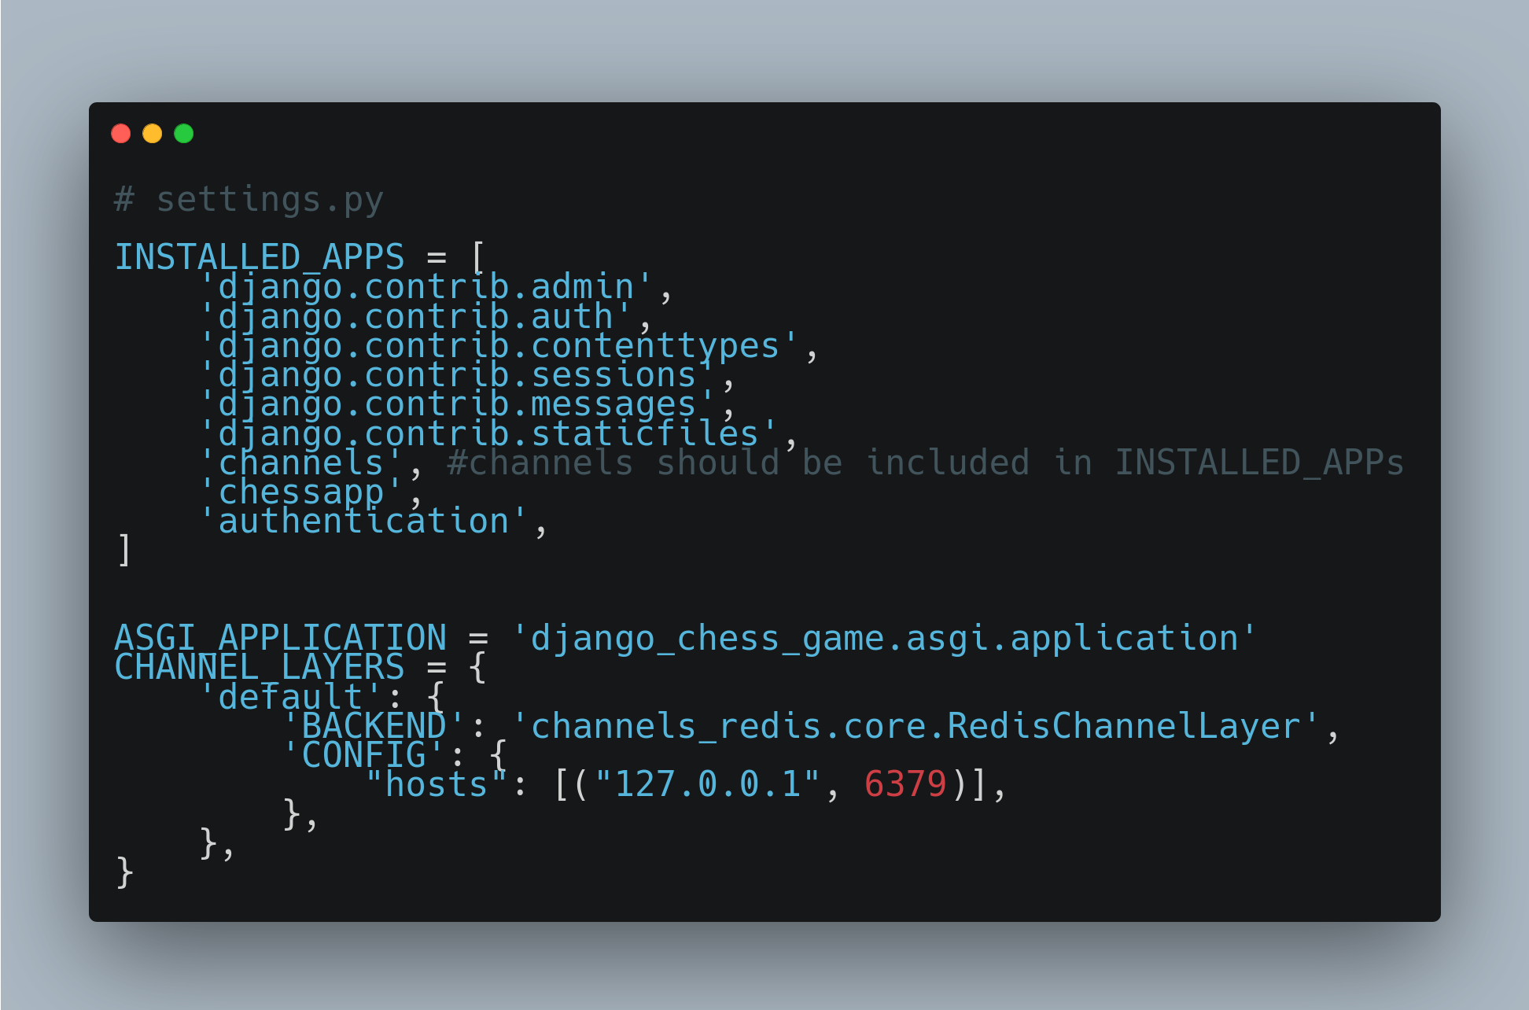

This appendix demonstrates settings.py configuration for using channels and redis in django project. The hosts part in config defines the url for redis server. Also channels need to be included in settings.py.

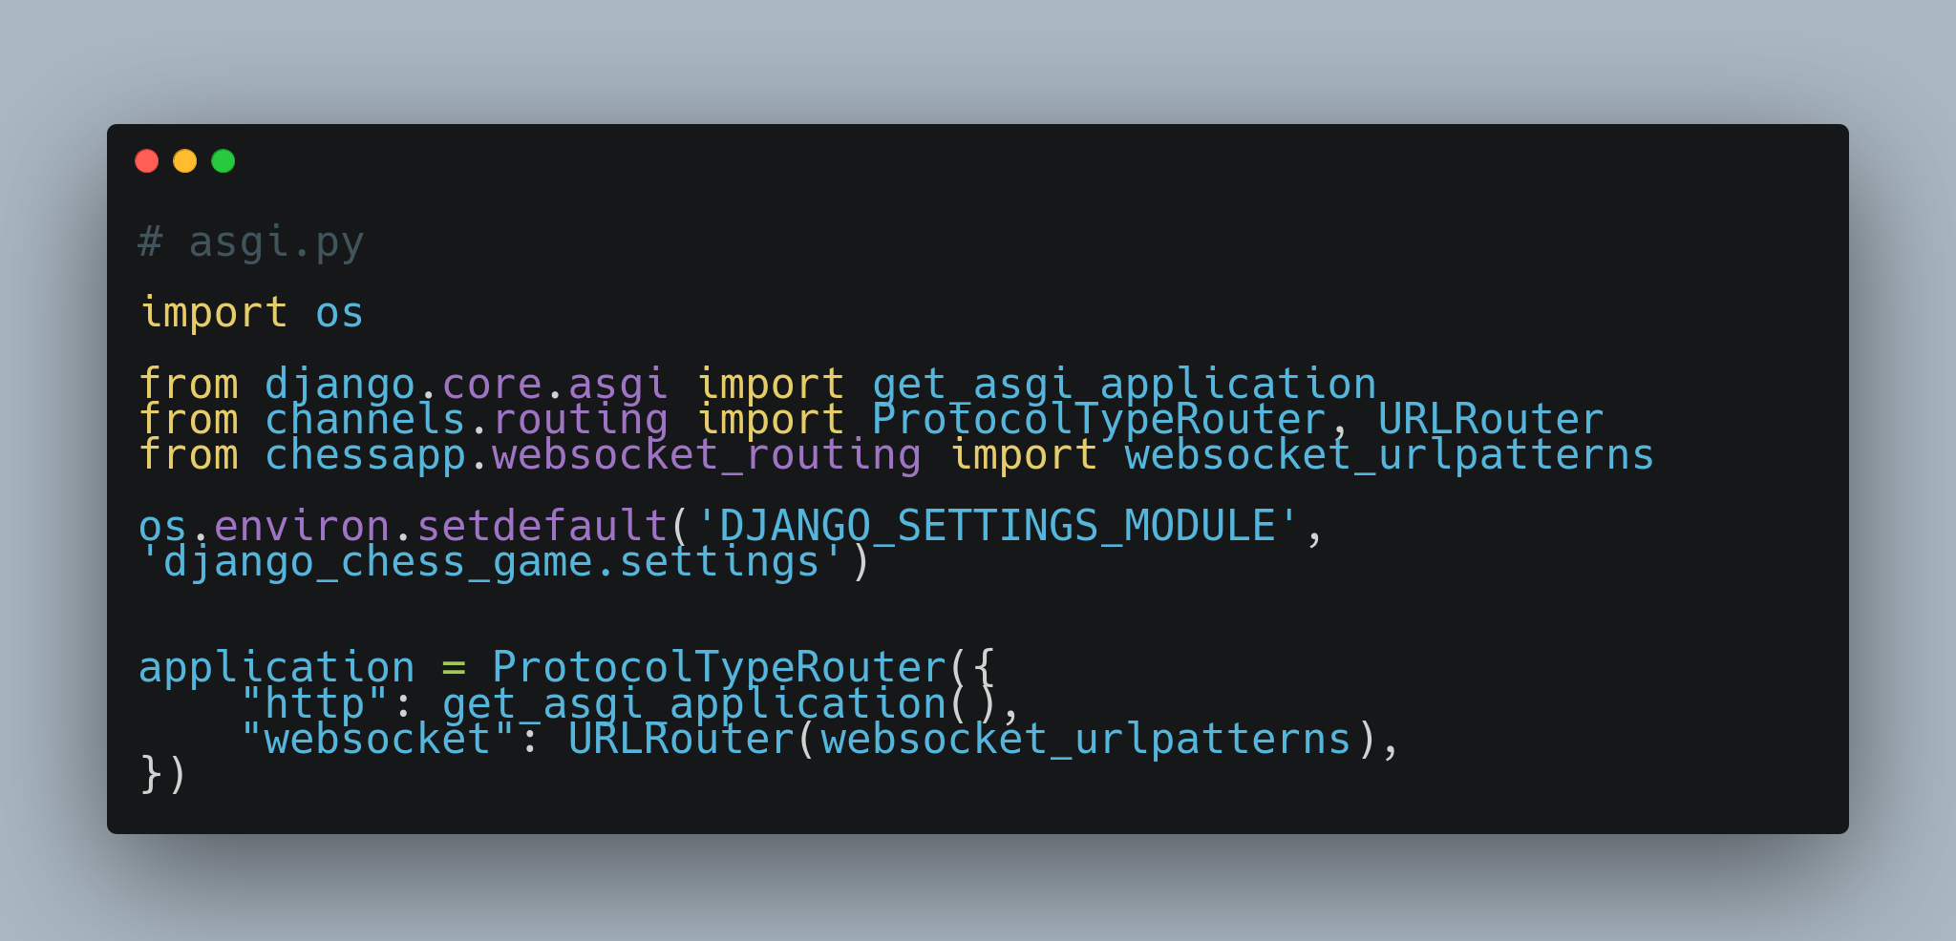

This snippet demonstrates the usage of asgi.py as this needs to configured for websockets.wsgi cannot work with websockets due to the constraint in channels library.  
So, asgi needs to be configured to route both http and websocket urls.

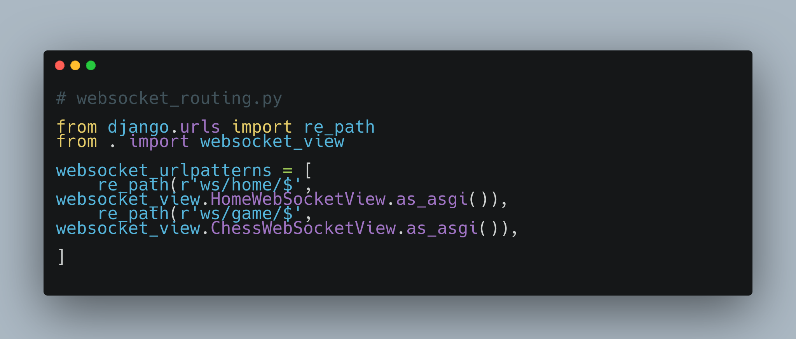

This snippet represents the websocket urls configuration. It is simply used as routing file for websockets.

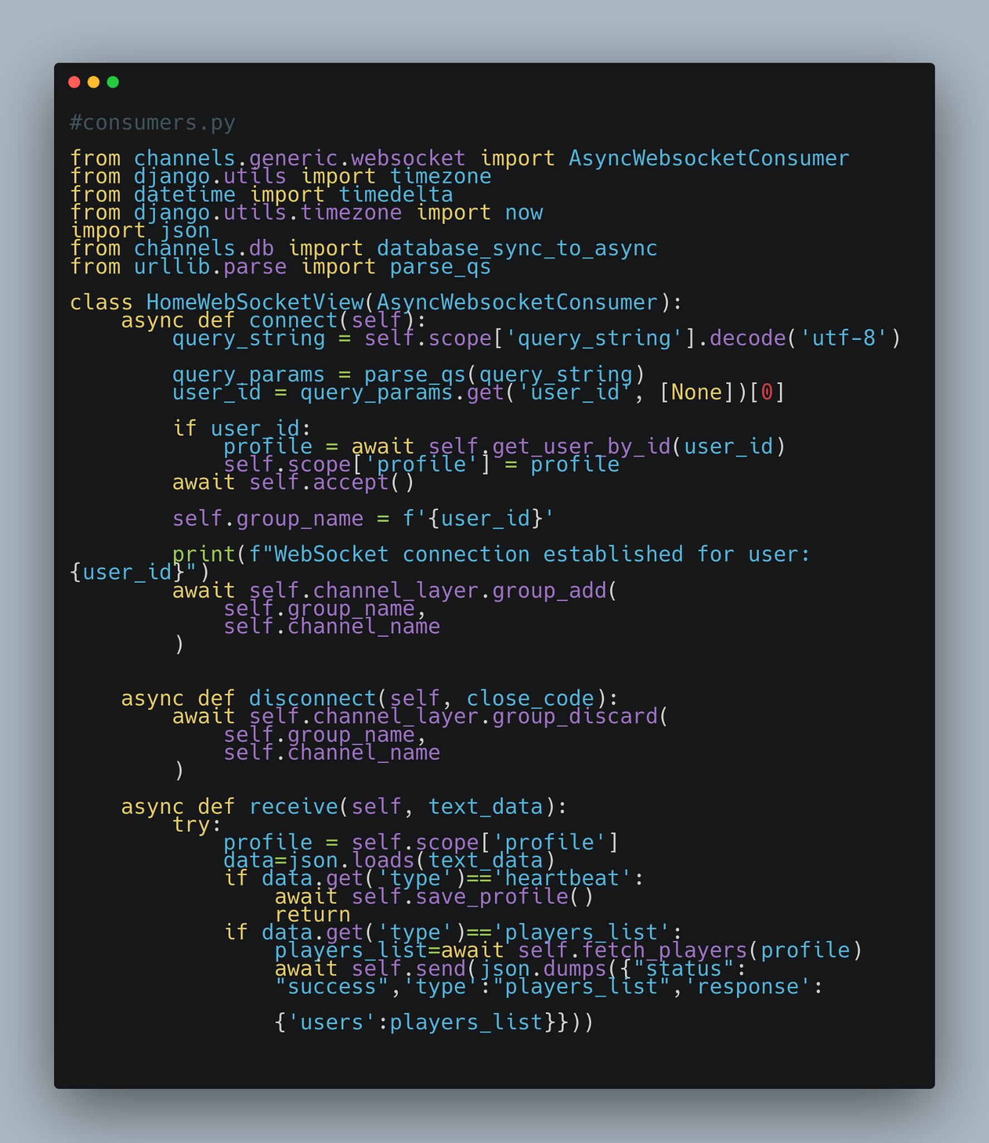

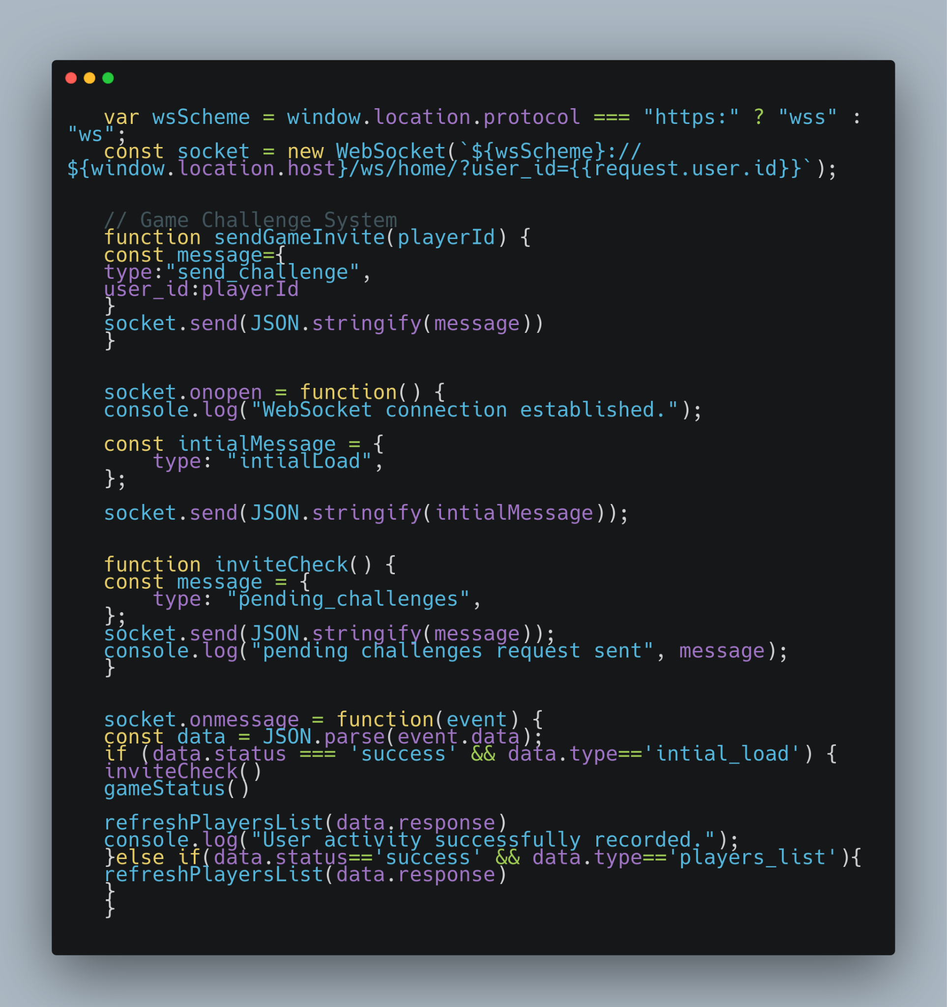

The two snippets defined above represent how websocket works by sending events and messages from frontend to backend.

Websocket is a bidirectional protocol which maintains a persistent connection between two ends. This allows us to send data from one end to another and vice-versa without having to reconnect again and again.

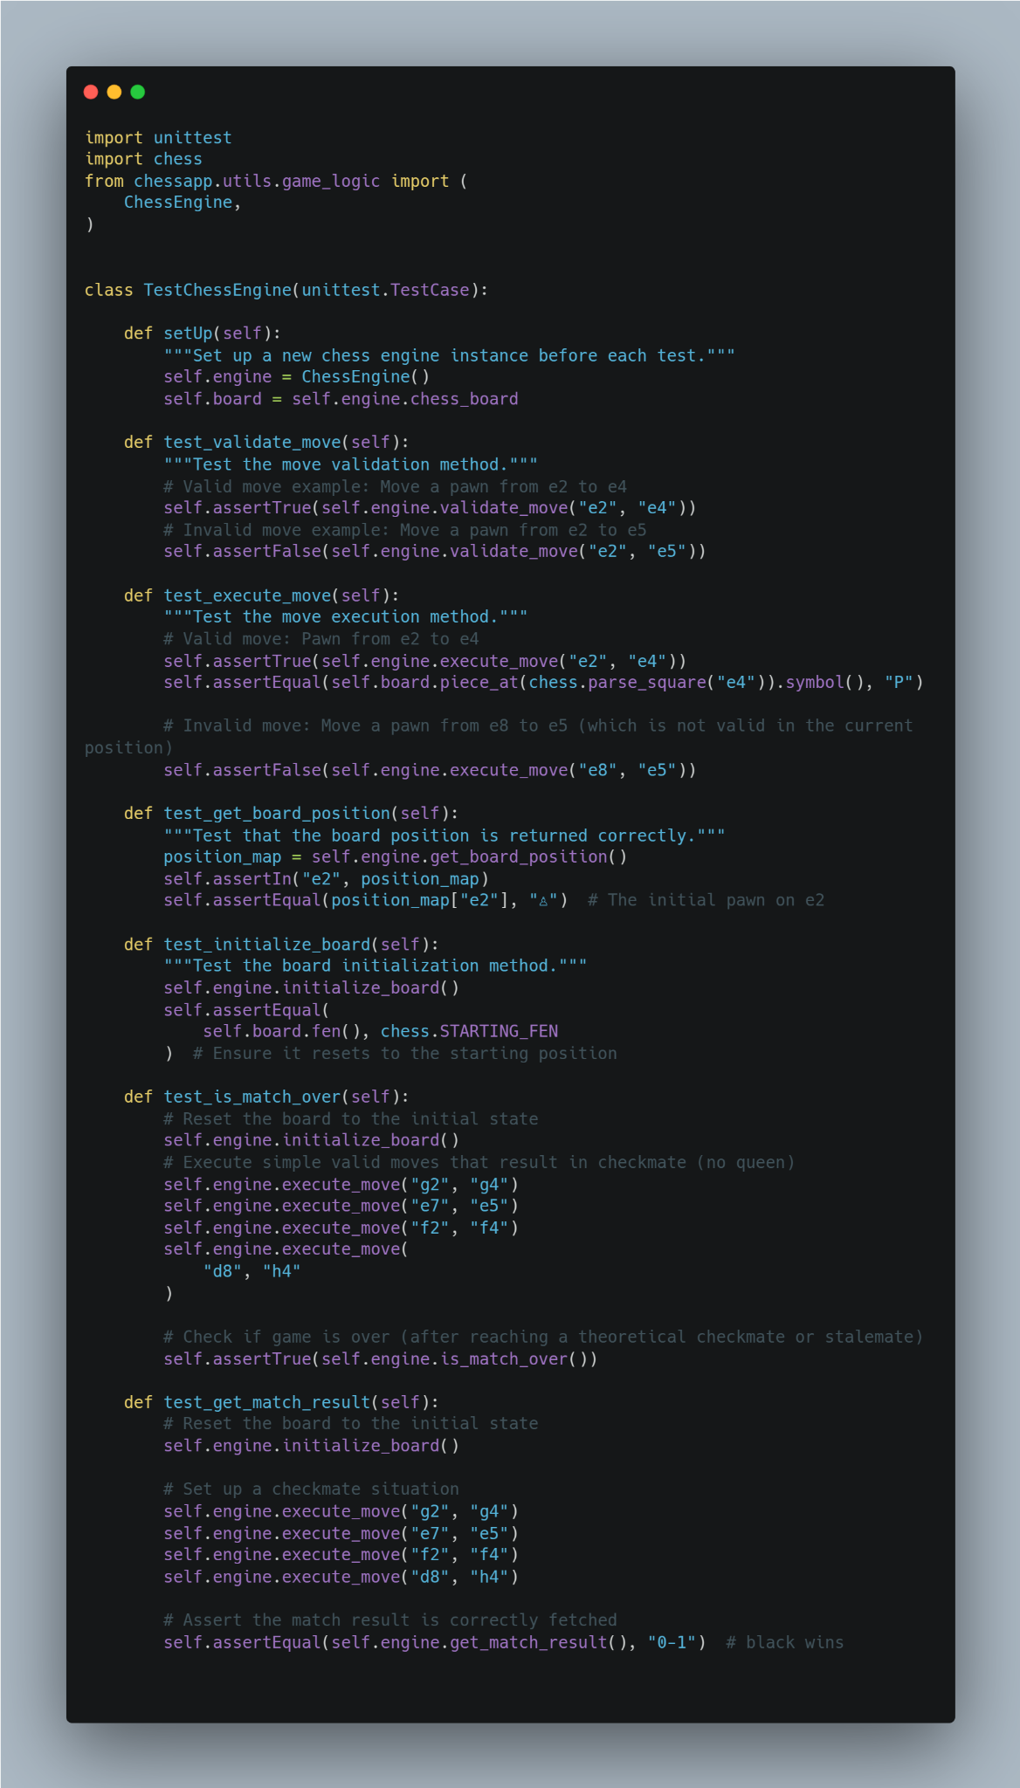

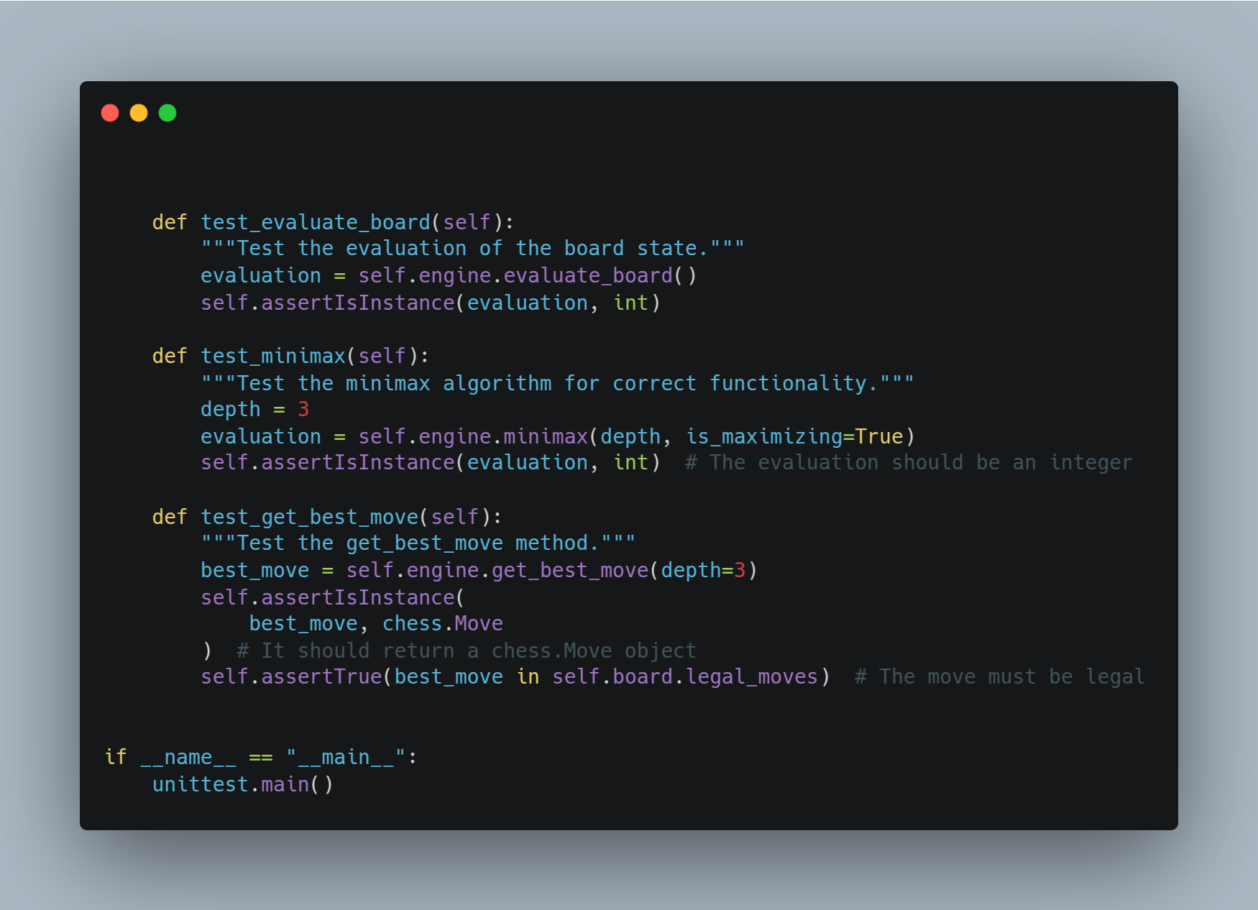

The above code snippet covers everything related to Unit Testing. The tests are performed for the main game logic mainly for evaluating moves and game status.

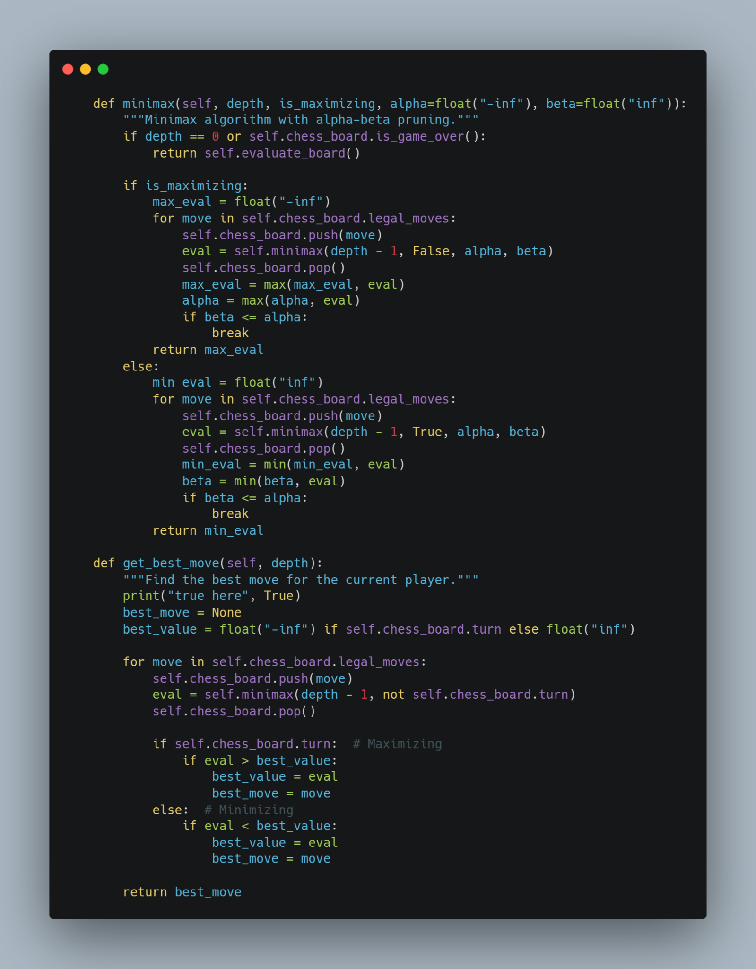

Above code is for implementing MinMax algorithm with alpha beta pruning to get the best move based on certain depth. The depth used in our code is 3..